MHAA-USNR System

A Dynamic Website for Alumni Association

**By team**

Antivirus

*MHAA-USNR System*

*Design Document*

|  |  |  |
| --- | --- | --- |
| **Team Members** | **Course** | **Instructor** |
| Shada Khanneh | CSIT 515  Software Engineering and Reliability | Dr. Hubert A. Johnson |
| Aseel Aloweiwi |
| Mira Boulos |
| Iman Almutairi |
| Amal Alamri |

November 9, 2020

Document Revision History

|  |  |  |  |
| --- | --- | --- | --- |
| **Name** | **Date** | **Reason for Changes** | **Version** |
| Shada Khanneh | November 9, 2020 | First Release | 1.0 |
| Mira Boulos | December 2, 2020 | Modification | 1.5 |
| Aseel Aloweiwi | December 7, 2020 | Match document to the current system state | 1.6 |
| Shada Khanneh | December 13, 2020 | Final Review and proofing | 1.7 |

Table of Content

1 Introduction 7

1.1 Purpose of the System 7

1.2 Project Goals 7

1.3 Purpose of the Current Document 7

2 Terms 7

3 System Overview 7

3.1 MHAA-USNR System Use-Case Diagram 8

4 MHAA-USNR System Class Diagram 9

5 Unified Pages Look 10

6 Homepage 12

7 History Page 13

8 FAQs 14

9 Alumni News 15

9.1 Alumni News User-View 15

9.1.1 News Information Page Look and Feel 16

9.1.2 View News Information Use-Case 17

9.1.3 View News Information Sequence Diagram 17

9.2 Alumni News Officers-View 18

9.2.1 Add News record 18

9.2.1.1 Add News form Look and Feel 18

9.2.1.2 Add News Record Use-Case 20

9.2.1.3 Add News Sequence Diagram 22

9.2.2 Delete News Records 23

9.2.2.1 Delete News Record Use-Case 23

10 Events 24

10.1 Upcoming-Events Users-View 25

10.1.1 Upcoming-Event Information Page 25

10.1.2 Event Registration 27

10.1.2.1 Event Registration Form Look and Feel 27

10.1.2.2 Payment Information Form 28

10.1.2.3 Event Registration Confirmation Page 30

10.1.2.4 Event Registration Use-Case 31

10.1.2.5 Event registration Sequence diagram 33

10.2 Upcoming-Events Officers-view 34

10.2.1 Add Upcoming-Event 35

10.2.1.1 Add Upcoming-Event form look and feel 35

10.2.1.2 Add Upcoming-Event Use-Case 36

10.2.1.3 Add Upcoming-Event Sequence Diagram 38

10.2.2 Delete Upcoming-Event Record 39

10.2.2.1 Delete Upcoming-Event Use-Case 39

10.3 Previous-Events Users-View 40

10.3.1 Previous-Event Information Page Look and Feel 40

10.3.2 View Previous-Event Information Use-Case 41

10.3.3 View Previous-Event Information Sequence Diagram 42

10.4 Previous-Events Officers-View 43

10.4.1 Add Previous-Event 43

10.4.1.1 Add Previous-Event Form Look and Feel 43

10.4.1.2 Add Previous-Event Use-Case 44

10.4.1.3 Add Previous-Event Sequence Diagram 46

10.4.2 Delete Previous-Event record 47

10.4.2.1 Delete Previous-Event Use-Case 47

11 Officers 48

11.1 Officers Login 49

11.1.1 Login/Logout Use-Case 50

11.1.1.1 Login Sequence Diagram 52

11.2 Forgot Password? 53

11.2.1 Forgot Password Use-Case 55

11.3 Forgot Username? 57

11.3.1 Forgot Username Use-Case 58

12 Donations 59

12.1 Payment Information Form 61

12.2 Payment Confirmation Page 61

12.3 Donate Use-Case 62

13 Unified Email Notifications 64

13.1 Details in the MHAA-USNR System Emails 65

13.1.1 Registration Confirmation Email 65

13.1.2 Donation Confirmation Email 65

13.1.3 Password Reset Email for Officers 66

13.1.4 Username Reset Email for Officers 66

14 Administrator 66

14.1 Administrator View 66

14.1.1 Administrator Change Privileges 66

14.1.2 Administrator Privileges Use-Case 67

Table of Figures

Figure 1 MHAA-USNR System Use-Case Diagram 8

Figure 2 4 MHAA-USNR System Class Diagram 9

Figure 3 Unified Pages Look 11

Figure 4 Homepage look 12

Figure 5 History page look 13

Figure 44 FAQs Look and Feel 14

Figure 6 Alumni News User-View look 15

Figure 7 News Information page look 16

Figure 8 View News Information SD 17

Figure 9 Alumni News Officers-View look 18

Figure 10 Add News Form 20

Figure 11 Add News sequence Diagram 22

Figure 15 Events Page Users-View 25

Figure 16 Upcoming-Event Information page look and feel 26

Figure 17 Event-Registration-Form 28

Figure 18 Payment-Information-Form 29

Figure 19 Event-Registration-Confirmation-Page 31

Figure 20 Event Registration Sequence Diagram 33

Figure 21 Events Page Officers-View 34

Figure 22 Add Upcoming-Event form 36

Figure 23 Add Upcoming-Event Sequence Diagram 38

Figure 27 Figure Previous-Event Information page look and feel 40

Figure 28 View Previous-Events Sequence Diagram 42

Figure 29 Add Previous-Event form 44

Figure 30 Add Previous-Event Sequence Diagram 46

Figure 34 Officers Page Look and Feel 48

Figure 35 Login Sequence Diagram 52

Figure 36 Forgot Password Page 53

Figure 37 Reset Password Page 54

Figure 38 Password Change Success Page 55

Figure 39 Forgot Username Page Look and Feel 57

Figure 40 Username confirmation page 58

Figure 41 Donations Page look and feel 60

Figure 43 Donation Confirmation Page Look and Feel 62

Figure 45 Unified Email Look and Feel 64

Table of Tables

Table 1 Fields in Add News Form 19

Table 2 Fields in Event-Registration Form 27

Table 3 Fields in Payment Information 28

Table 4 Content of Event Registration Confirmation Page 30

Table 5 Fields Details in Add Upcoming-Event form 35

Table 6 Fields Details in Add Previous-Event form 43

Table 7 Fields Details in Login Box 49

Table 8 Donation Page Fields Details 59

Table 10 Content of Donation confirmation Page 61

# Introduction

“MHAA-USNR” system is a dynamic website that will be designed and built to serve the needs of the Maggotty High Alumni Association - US Northern Region. The “MHAA-USNR” website will aim to facilitate the Association’s targeted objectives and provide the website’s visitors/users with an easy and simple way to benefit from the organization’s offered services.

## Purpose of the System

The Maggotty High Alumni Association website will be available for public use through the web interface. Users will be updated regarding the school’s news, register for events, and make donations. The organization’s officers of the Maggotty High School Alumni association will have control over the system. Officers will be able to create events and update school news. The system promises to deliver its users an easy payment and donation process by providing most known payment methods (credit cards, debit card and PayPal). The website will display a background history of the school and will provide visitors with information on how the donations contribute in developing a better learning environment for the school’s students.

## Project Goals

This project aims to offer a user-friendly website that will enable its users to easily navigate through the website and utilize the provided features of the system such as event registration and fund donations. Another goal of this project is to offer the school’s officers the ability to create events and add news.

## Purpose of the Current Document

The purpose of this design document for the MHAA-USNR system is to include a detailed description of the system look and feel in terms of pages overall look, navigation bars, buttons, and fields in each page in the system. In addition, this document will illustrate how the system’s functionalities and procedures will be designed to achieve the system’s objectives.

# Terms

Refer to the glossary in appendix [A] to find an abbreviation definition.

# System Overview

The MHAA-USNR system will be designed as a dynamic website, with mainly the following goals:

1. Grant users’ navigation ability between system pages.
2. Allow users to view specified public pages.
3. Enable users to register to “Events” via the website pages.
4. Provide data input forms to facilitate ease of input for users.
5. Give the Officer’s permission to Add and Delete specified content on the MHAA-USNR website.
6. Add Payment integration for donations and event registration; this includes PayPal interface.

## MHAA-USNR System Use-Case Diagram

The below use-case diagram illustrates the MHAA-USNR systems’ actors and the functions they will trigger.

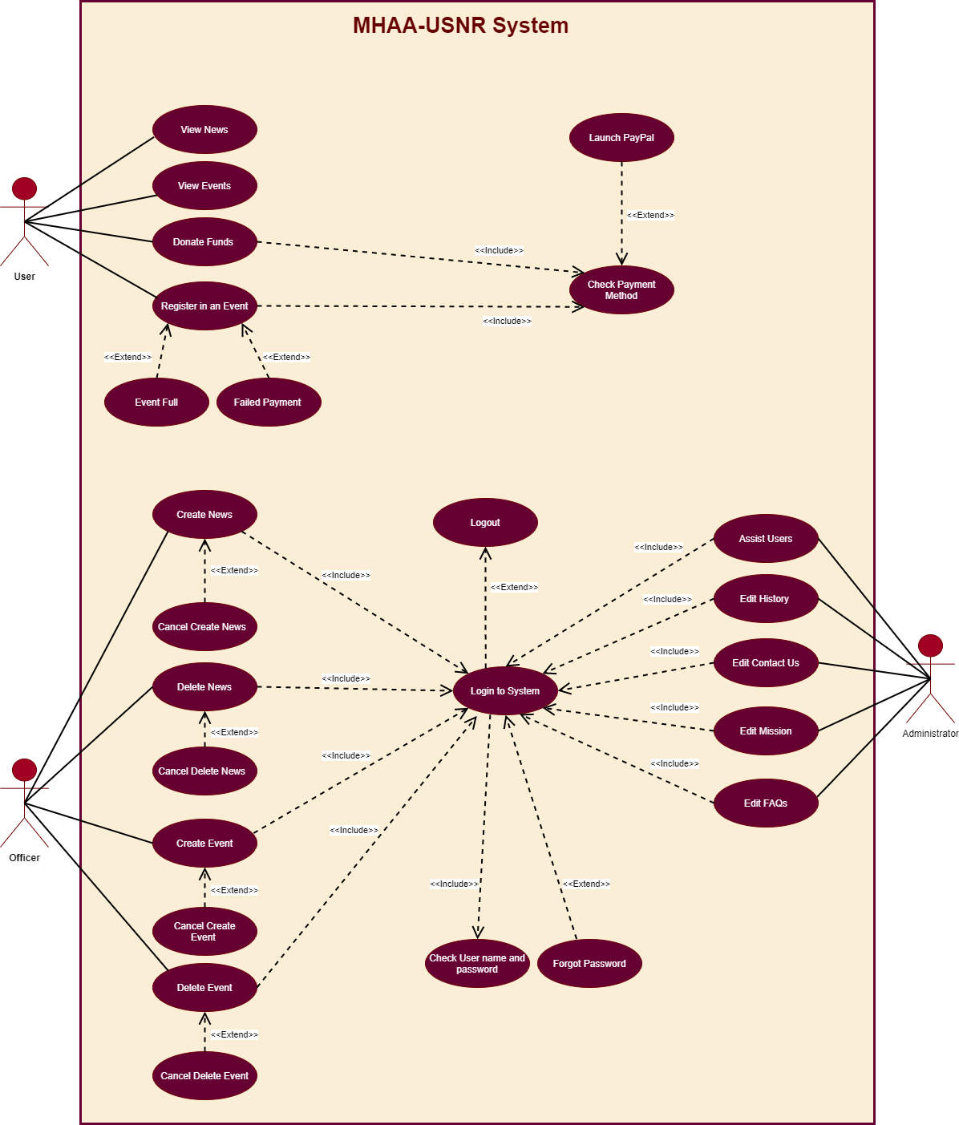

Figure MHAA-USNR System Use-Case Diagram

# MHAA-USNR System Class Diagram

The below class diagram describes the structure of the MHAA-USNR system and shows the system's classes, their attributes, operations, and the relationships among objects. (Please refer to appendix [B] for a landscaped image).

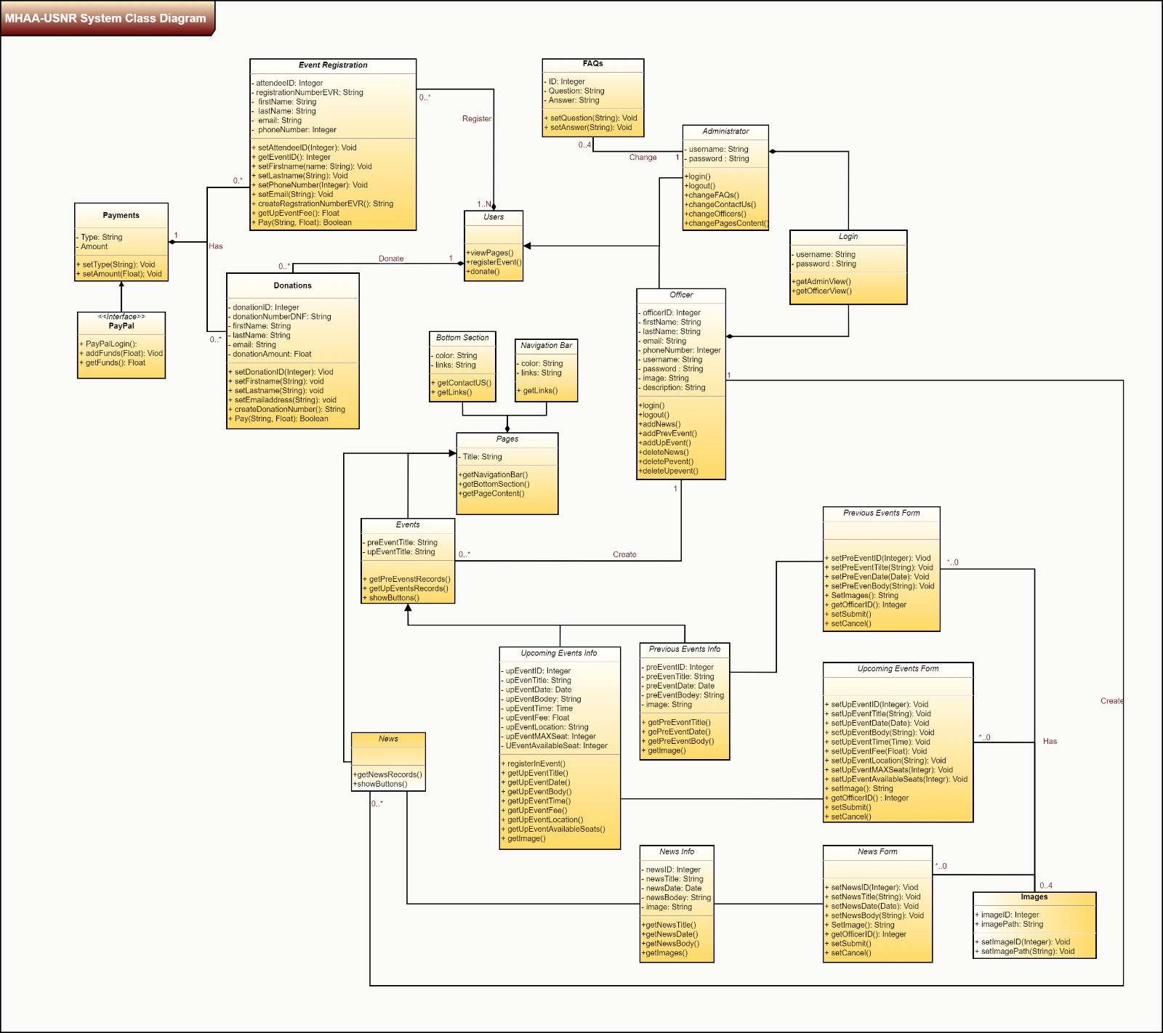

Figure 4 MHAA-USNR System Class Diagram

# Unified Pages Look

All pages across the MHAA-USNR website must have the following in addition to the page’s specified content which will be demonstrated separately for each page:

1. Color Scheme

All pages across the website must reflect the agreed upon colors of Burgundy and Page-Gold

1. System Title and Logo

Each page must reflect the system’s logo and name at the top-left corner.

1. A Navigation Bar

The navigation bar will be the main means to navigate throw the MHAA-USNR website and move conveniently from one screen to the other. The navigation bar must be reflected on every page of the system and must be consistent throughout the website pages. This consistency includes the following aspects:

* The navigation bar must reflect the system agreed upon color scheme (burgundy and Page-Gold).
* The navigation bar must reside on the top of the screen.
* All the navigation titles in the navigation bar must also be reflected on the bottom of the page as hyperlinks for usability.
* The navigation bar must include the following titles in the following order:
  1. Homepage ---> directs the user to the homepage screen.
  2. History ---> directs the user to the history screen.
  3. Alumni News---> directs the user to the Alumni news screen.
  4. Events ---> directs the user to the events screen.
  5. Officers ---> directs the user to the officers’ screen.
  6. Donate to the Association ---> directs the user to donations screen.

1. Bottom Section

* The bottom of each page must be highlighted to represent a separate section and must reflect the following:
* **Contact us:** a title that will reflect a phone icon, a letter icon, and a location icon, with the corresponding data number specified by the client.
* **Links:** a list of all navigation links in the MHAA-USNR website.
* **FAQs:** will be a clickable link that directs the users to the FAQs page that is described in detail in section (‎13 FAQs).

**The figure below illustrates the unified look across system pages/screens:**

Figure Unified Pages Look

# Homepage

The Homepage will be the primary access point to the website. Upon clicking/entering the website’s URL, users will be directed to the Homepage. The Home page design will be as follows:

* As of all pages/screens on the MHAA-USNR website this page must follow the unified pages look specified in section ‎(5.1 Unified Pages look).
* Under the navigation bar the page will display a paragraph of the title “Our Mission” and a text paragraph that reflects user specified content.

**The figure below illustrates the Homepage look and feel:**

Figure Homepage look

# History Page

The History page design will be as follows:

* As of all pages/screens on the MHAA-USNR website this page must follow the unified pages look specified in section ‎(5.1 Unified Pages look).
* Under the navigation bar the page will display a paragraph of the title “History” and a text paragraph that reflects user specified content.

**The figure below illustrates the History page look and feel:**

Figure History page look

# FAQs

The FAQs page design will be as follows:

* The FAQs will be accessible from the bottom section that appears across the system pages.
* As of all pages/screens on the MHAA-USNR website this page must follow the unified pages look specified in section ‎(5.1 Unified Pages look).
* The page will display records of questions and answers preset and defined by the client.
* The administrator will be given the permission to change the Questions and Answers content/text.

**The figure below illustrates the look and feel of FAQs Page:**

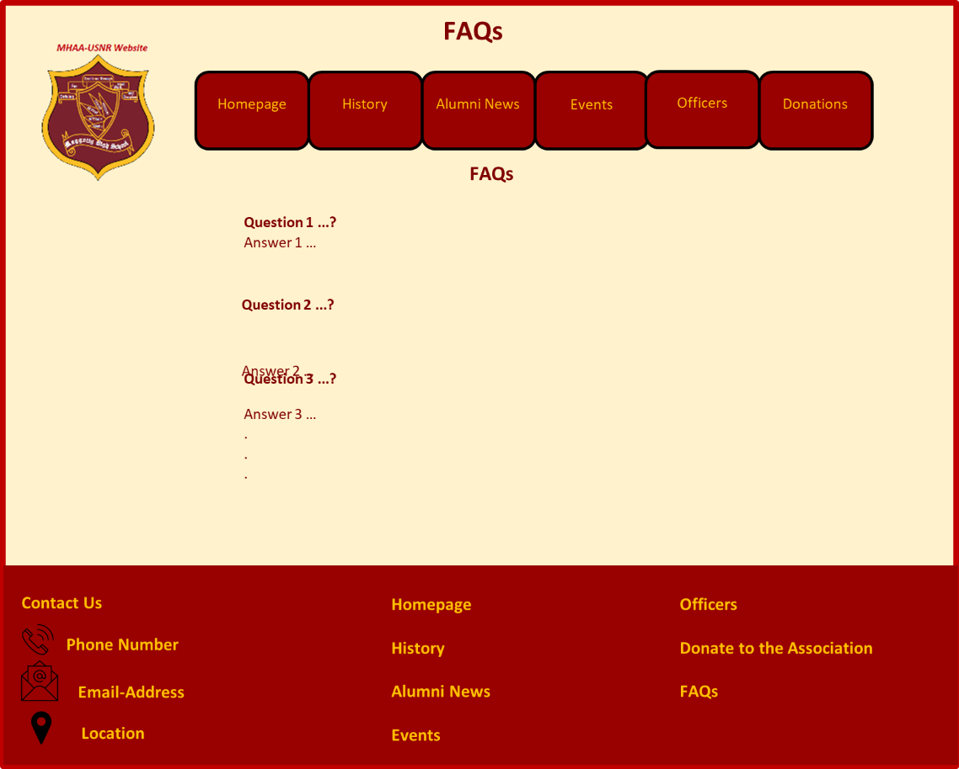

Figure FAQs Look and Feel

# Alumni News

The Alumni page news will be a destination for users to view any updates and news posted by the association. In addition, logged in officers will be given the ability to add and delete a News record via this page.

The Alumni News page will have two different views

1. User-View ---> for any user who is not logged in to the system
2. Officers-View---> for officers with preset login username and password who completed the login process successfully.

## Alumni News User-View

In the user view the page must appear as follows:

* As of all pages/screens on the MHAA-USNR website this page must follow the unified pages look specified in section ‎(5.1 Unified Pages look).
* Under the navigation bar this page will display up to 5 News titles with a thumbnail picture if available.

**The figure below illustrates the Alumni News User-View look and feel:**

Figure Alumni News User-View look

### News Information Page Look and Feel

Users will access this page by clicking on a News record form the Alumni News screen. Once the “News information” page is accessed the following must appear to the user:

* The News record title.
* The News record date.
* News body (description text).
* Up to 4 related images.

**The figure below illustrates the News Information page look and feel:**

Figure News Information page look

### View News Information Use-Case

|  |  |  |  |
| --- | --- | --- | --- |
| **Use Case Definition** | | | |
| **Actors** | | User | |
| **Description** | | Allows the user to view and read a news record | |
| **Preconditions** | | Actor must enter the website URL on a supported device browser. | |
| Main Flow | | | |
| No. | Actor Action | | System Response |
|  | Actor clicks on the Alumni News tab from the Navigation Bar | | * System directs the actor to the Alumni News page. * System displays up to 5 news records as clickable links. |
|  | Actor clicks on a News record link. | | * System directs the user to the “News Information” page of the news record in question. |
| Alternative Flow | | | |
| None | | | |
| Exceptional Flow | | | |
| None | | | |
| Post Conditions | | | |
| None | | | |

### View News Information Sequence Diagram

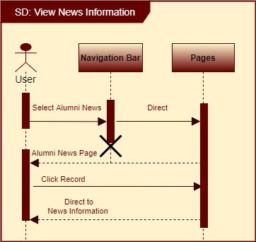

Figure View News Information SD

## Alumni News Officers-View

The Alumni News page will appear as follows if the system detects that the user is an officer who is logged in successfully to the system:

* As of all pages/screens on the MHAA-USNR website, this page must follow the unified pages look specified in section ‎(5.1 Unified Pages look).
* Under the navigation bar this page will display up to 5 News titles with a thumbnail picture if available.
* Action Buttons will appear which are:

1. Add button ---> to give the officers the ability to add news record.
2. Delete button---> to give the officers the ability to delete news record

**The figure below illustrates the Alumni News Officers-View page look and feel and illustrate the presence and the position of the buttons:**

Figure Alumni News Officers-View look

### Add News record

* Officers will be able to click on the “Add News” button that appears to Officers in the Alumni News page to access the **“Add Form”** and create a new record.
* Officers will be able to click on the “Delete” button that appears to Officers in the Alumni News page next to each record.

#### Add News form Look and Feel

The news form must contain the following fields:

Table Fields in Add News Form

|  |  |  |  |  |  |  |
| --- | --- | --- | --- | --- | --- | --- |
| Label | Description | Value | Format | Type | Size | Required |
| Title | News Title field | User Specified | Text | Characters | 50 Bytes | Yes |
| Date | Current day date | System Input | mm/dd/yyyy | Characters | 3 Bytes | Yes |
| Body | News content description field | User Specified | Text | Characters | 3000 Bytes | Yes |
| Attachments | Images and files | User Specified | Image | PNG, GIF, PDF | 5MB/item ,4 items in total. | No |
| Record Row Number | Represents the row number for the record to be replaced | User Specified | Numerical | Integer | 1 Byte | Yes |

The “Add News” form contains the following buttons:

* **Add** ---> saves changes and reflects the new record on the Alumni News page.
* **Cancel** ---> reverts all changes.

**The figure below illustrates the “Add Form” look and feel:**

Figure Add News Form

#### Add News Record Use-Case

|  |  |  |  |  |
| --- | --- | --- | --- | --- |
| **Use Case Definition** | | | | |
| **Actors** | | | Officer | |
| **Description** | | | Allows Officers to create a news record and reflect it on the Alumni News page | |
| **Preconditions** | | | Officer must complete login Use-Case main flow successfully (‎10.1.1.1 Login Use-Case) | |
| Main Flow | | | | |
| No. | | Actor Action | | System Response |
|  | | Actor clicks on the Alumni News tab from the Navigation Bar | | * System directs the actor to the Alumni News page. * System displays up to 5 news records as clickable links. * System confirms current user is logged in to the system and displays the Add and Delete buttons. |
|  | | Actor clicks “Add News” button | | System directs the user to the “Add Form”. |
|  | | Actor fills all mandatory fields correctly and presses the “Add” button | | * System confirms all mandatory fields are filled correctly including the record row number. * System places the new record information in the corresponding row number. * System reflects the new News title on the “Alumni News” page as clickable link. * System creates the corresponding “News Information” page for the new News record. |
| Alternative Flow | | | | |
| No. | Actor Action | | | System Response |
|  | Actor fills all mandatory fields correctly and presses the “Cancel” button | | | System does not reflect any changes and returns the Officer to the “Alumni News” page. |
| Exceptional Flow | | | | |
| No. | Actor Action | | | System Response |
|  | Actor fails to fill all mandatory fields correctly and presses “Add” button | | | System displays error message containing the fields labels that need to be filled or corrected. |
|  | Actor clicks on the Alumni News tab from the Navigation Bar | | | * System directs the actor to the Alumni News page. * System displays up to 5 news records as clickable links. * System confirms current user is **not** logged in to the system and hides the Add and Delete buttons. |
| Post Conditions | | | | |
| Replaced News records must be archived in database | | | | |

#### Add News Sequence Diagram

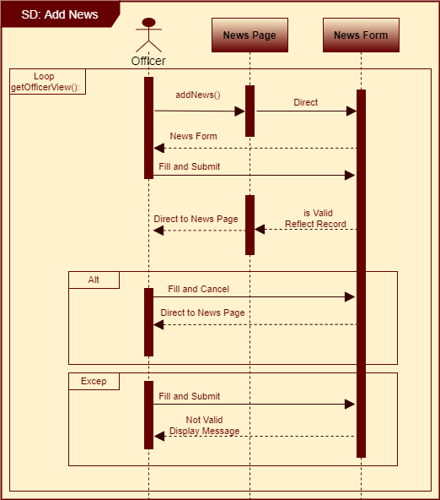

Figure Add News sequence Diagram

### Delete News Records

The “Delete” button in the Alumni News Officers-View will allow officers to delete News records from the records list displayed on this screen and delete them.

* The Delete button will have **burgundy** color to indicate its **Active state**.
* The Delete button will be disabled (unclickable) by default and marked with **gray** color to indicate its **Disabled state**.

#### Delete News Record Use-Case

|  |  |  |  |  |
| --- | --- | --- | --- | --- |
| **Use Case Definition** | | | | |
| **Actors** | | | Officer | |
| **Description** | | | Allows Officers to delete News records and remove them from the Alumni News page | |
| **Preconditions** | | | Officer must complete login Use-Case main flow successfully (‎10.1.1.1 Login Use-Case) | |
| Main Flow | | | | |
| No. | | Actor Action | | System Response |
|  | | Actor clicks on the Alumni News tab from the Navigation Bar | | * System directs the actor to the Alumni News page. * System displays up to 5 news records as clickable links. * System confirms current user is logged in to the system and displays the Add and Delete buttons. |
|  | | Actor clicks Delete button next to the desirable record to be deleted. | | * System asks the actor to confirm deletion. |
|  | | Actor clicks “yes” to confirm. | | * System removes the corresponding record from Alumni News page. * System displays a delete confirmation message. * System disables the delete button. |
| Alternative Flow | | | | |
| No. | Actor Action | | | System Response |
| None | | | | |
| Exceptional Flow | | | | |
| No. | Actor Action | | | System Response |
|  | Actor clicks on the Alumni News tab from the Navigation Bar | | | * System directs the actor to the Alumni News page. * System displays up to 5 news records as clickable links. * System confirms current user is **not** logged in to the system and hides the Add and Delete buttons. |
| Post Conditions | | | | |
| None | | | | |

# Events

The Alumni page news will be a destination for users to view any events Upcoming or Previous posted by the association. In addition, logged in officers will be given the ability to add and delete an upcoming or Previous event record via this page.

1. The Events page will display two Events categories Upcoming-Events and Previous-Events.

* **Upcoming-Events** willdisplay records of events that will take place sometime in the future. Officers will be able to Add and reflect Upcoming-Events records on the Events page under the Upcoming-Events title. Afterwards, users will be able to click on a record to view the event details and register to attend it
* **Previous-Events** will display records of past events under its title. Officers will be able to add Previous-event record and users will be able to click on the record to view more details about it.

1. The Events page will have two different views

* **User-View** ---> for any user who is not logged in to the system
* **Officers-View**---> for officers with preset login username and password who completed the login process successfully.

## Upcoming-Events Users-View

In the user view the page must appear as follows:

* As of all pages/screens on the MHAA-USNR website, this page must follow the unified pages look specified in section ‎(5.1 Unified Pages look).
* In the Events page, up to 5 Upcoming-Events records and Previous-Events records will be visible to the users. These events titles/records will act as clickable links that direct the user to the corresponding **event information page**.

**The figure below illustrates the Event page look and feel from the User-View:**

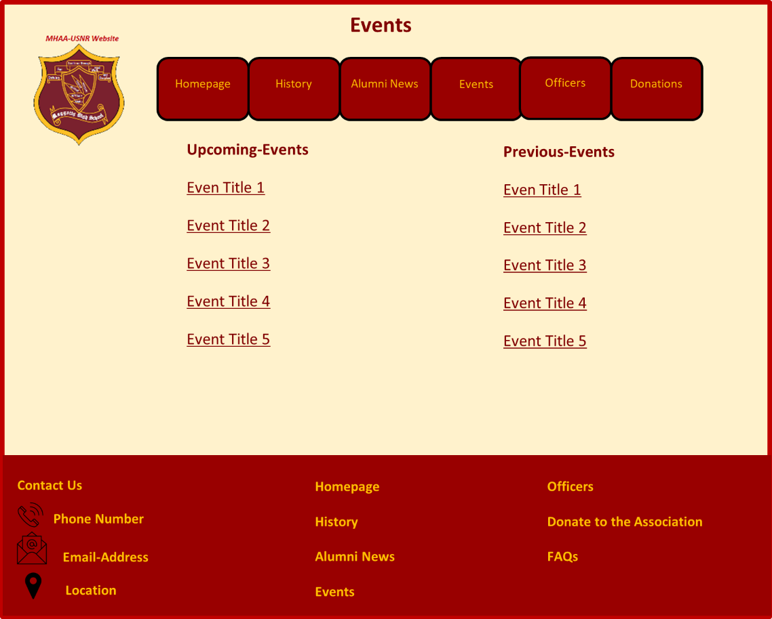

Figure Events Page Users-View

### Upcoming-Event Information Page

Users will access this page by clicking on an Upcoming-event record form the event screen. In the event information view the user must be able to see the following:

* Event details, Event name, Date, Time, Description, Related images, Seats availability, Location, and registration fee.
* Users must be able to see an action button labeled as “Register to this Event”
* The “Register to this Event” button will be active and marked in burgundy color if the available seats number is bigger than 0.
* If the available seats number is 0, the system will deactivate this button and change its color to gray to mark its inactive state.
* When the Register to this Event” button is active and the user clicks it, he/she must be directed to the **“Event Registration” form**.

**The figure below illustrates the look and feel of the event information page:**

Figure Upcoming-Event Information page look and feel

### Event Registration

In the upcoming-event information page, once the user clicks on the button “Register to this event”, the system will direct them to the “Event Registration form”.

The table below table describes the fields on the “Event Registration” Form.

#### Event Registration Form Look and Feel

The event registration form will contain the following fields:

Table Fields in Event-Registration Form

|  |  |  |  |  |  |  |
| --- | --- | --- | --- | --- | --- | --- |
| Label | Description | Value | Format | Type | Size | Required |
| First Name | Attendee first name | User Specified | Text | Characters | 50 Bytes | Yes |
| Last Name | Attendee last name | User Specified | Text | Characters | 50 Bytes | Yes |
| Email address | Attendee email address | User Specified | Text | Characters | 350 Bytes | Yes |
| Phone Number | Attendee phone number | User Specified | Number | Integer | 4 Bytes | No |

The **“Event Registration form”** contains the following Buttons:

* Register ---> takes the user to the **“Payment Information”** form.
* Cancel ---> reverts changes.

**The figure below illustrates the look and feel of the “Event Registration” form:**

Figure Event-Registration-Form

#### Payment Information Form

The user will be directed to this page after he/she fills all the mandatory fields in the “Event registration” form and presses the “Register button”. **The “Payment Information” form consist of the following fields and buttons:**

The table below table describes the fields on the “Payment Information” Form.

Table Fields in Payment Information

|  |  |  |  |  |  |  |
| --- | --- | --- | --- | --- | --- | --- |
|  | Card Information | | | | | |
| Label | Description | Value | Format | Type | Size | Required |
| First Name | card holder first name | User Input | Text | Characters | 50 Bytes | Yes |
| Last Name | card holder last name | User Input | Text | Characters | 50 Bytes | Yes |
| Credit Card number | Card number | User Input | Number | Integer | 4 Bytes | Yes |
| Security Code | security code on card | User Input | Number | Integer | 4 Bytes | Yes |
| Expiration month | Card Expiration month | User Input | MM | Numeric | 3 Bytes | Yes |
| Expiration Year | Card Expiration Year | User Input | YYYY | Numeric | 3 Bytes | Yes |
|  | Billing address | | | | | |
| Label | Description | Value | Format |  | Size | Required |
| Street Address | Address associated with the Card | User Input | Text | Characters | 50 Bytes | Yes |
| Street Address line 2 | Address associated with the Card | User Input | Text | Characters | 50 Bytes | No |
| City | City associated with the Card | User Input | Text | Characters | 50 Bytes | Yes |
| State/Province | State/Province associated with the Card | User Input | Text + drop down list | Characters | 50 Bytes | Yes |
| Postal/Zip Code | Postal/Zip Code | User Input | Number | Integer | 4 Bytes | Yes |
| Country | County associated with the Card | User Input | Text + drop down list | Characters | 50 Bytes | Yes |

The **“Payment Information” form** also contains a **Pay** button that allows the users to post their payment. After pressing Pay button, if the payment is successful, the user will be directed to a confirmation page.

**The figure below illustrates the look and feel of the “Payment Information form:**

Figure Payment-Information-Form

#### Event Registration Confirmation Page

After completing the Registration form and the payment form successfully, the user will be directed to this page to view his/her receipt number and confirmation details.

The confirmation page will view the following information

Table Content of Event Registration Confirmation Page

|  |  |
| --- | --- |
|  | Description |
| A thank you message, | **Thank You!**  **Your registration is successful please print this page for future reference** |
| Confirmation number | A unique number generated automatically for each new registration. The number must contain letters and number. |
| Name | The system will retrieve the first name and last name the user entered in the “Event Registration” form. |
| Email | The system will retrieve the Email Address the user entered in the “Event Registration” form. |
| Phone Number | The system will retrieve the Phone Number the user entered in the “Event Registration” form. |
| Event Name | The system will retrieve the Event title from the Event Information page. |
| Event date | The system will retrieve the Event date from the Event Information page. |
| Event Time | The system will retrieve the Event time from the Event Information page. |
| Event Location | The system will retrieve the Event location from the Event Information page. |
| Contact us message | Displays Client specified email address and phone number |
| Back to home link | A clickable link takes the user back to the website’s Homepage. |

**The figure below illustrates the look and feel of the Payment Confirmation Page:**

Figure Event-Registration-Confirmation-Page

#### Event Registration Use-Case

|  |  |  |  |  |
| --- | --- | --- | --- | --- |
| **Use Case Definition** | | | | |
| **Actors** | | | Users | |
| **Description** | | | Allows users to register to an Upcoming-Event ad submit the registration fee | |
| **Preconditions** | | | Actor must enter the website URL on a supported device browser. | |
| Main Flow | | | | |
| No. | | Actor Action | | System Response |
|  | | Actor clicks on the “Events” tab from the Navigation Bar | | * System directs the actor to the “Events” page. * System displays up to 5 records of Upcoming-Events and 5 records of Previous-Events as clickable links. |
|  | | Actor clicks on an Upcoming-Event record. | | * System directs the user to the “upcoming-Event Information Page”. * System confirms “Available seats” does not equal 0 and activates the “Register to this Event” button and sets it is color to burgundy. * System confirms “Event Date” not expired and activates the “Register to this Event” button and sets it is color to burgundy. |
|  | | Actor clicks the “Register to this Event” button | | System directs the user to the “Registration Form”. |
|  | | Actor fills all mandatory fields correctly and presses “Register” button | | System direct the user to the payment Information form |
|  | | Actor fills all mandatory fields correctly and presses “Pay” button. | | * System adds the user information as attendee to the event in question. * System decrements available seats number * System generates a Registration number * System directs the user to the “Event Registration Confirmation Page”. * System sends the registration confirmation to the entered email address. |
| Alternative Flow | | | | |
| No. | Actor Action | | | System Response |
|  | Actor fills all mandatory fields correctly and presses the “Cancel” button | | | System does not reflect any changes and returns the user to the “Upcoming-Event information” page. |
| Exceptional Flow | | | | |
| No. | Actor Action | | | System Response |
|  | Actor fails to fill all mandatory fields correctly and presses “Register” button | | | System displays error message containing the fields labels that need to be filled or corrected. |
|  | Actor fails fills all mandatory fields correctly and presses “Pay” button | | | System displays error message containing the fields labels that need to be filled or corrected. |
|  | Actor clicks on an Upcoming-Event title. | | | * System directs the user to the “upcoming-Event Information Page”. * System confirm “Available seats” equal 0 and deactivates the “Register to this Event” button and sets it is color to gray. |
|  | Actor clicks on an Upcoming-Event title. | | | * System directs the user to the “upcoming-Event Information Page”. * System confirms “Event Date” is expired and deactivates the “Register to this Event” button and sets it is color to gray. |
| Post Conditions | | | | |
| Registered user must be reflected as attendee to the event | | | | |

#### Event registration Sequence diagram

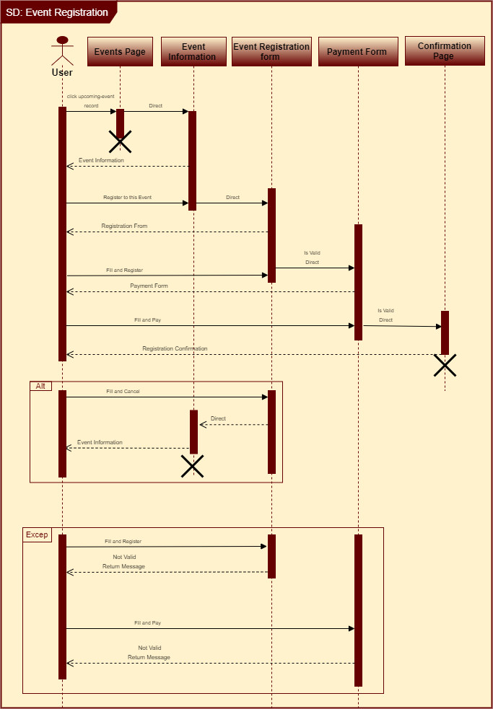

Figure Event Registration Sequence Diagram

## Upcoming-Events Officers-view

The Events page will appear as follows if the system detects that the user is an officer who is logged in successfully to the system:

* As of all pages/screens on the MHAA-USNR website this page must follow the unified pages look specified in section ‎(5.1 Unified Pages look).
* Under the navigation bar this page will display up to 5 Upcoming-Events records and Previous-Events records. These events titles/records will act as clickable links that direct the user to the corresponding **event information page**.
* Action Buttons will appear under and next to the Upcoming-Events records and Previous-Events records.

1. Add button ---> to give the officers the ability to add news record.
2. Delete button---> to give the officers the ability to delete news record

**The figure below illustrates the Events page Officers-View page look and feel and illustrate the presence and the position of these buttons:**

Figure Events Page Officers-View

### Add Upcoming-Event

In the Events Page, an “Add News” button Under the Upcoming-Events title will appear to logged in officers.   
Once an officer clicks the “Add News” button, the system will direct him/her to the “Upcoming-Event” form.

#### Add Upcoming-Event form look and feel

The news form must contain the following fields:

Table Fields Details in Add Upcoming-Event form

|  |  |  |  |  |  |  |
| --- | --- | --- | --- | --- | --- | --- |
| Label | Description | Value | Format | Type | Size | Required |
| Event description | Event body | User Input | Text | Character | 3000 Bytes | Yes |
| Title | Event Title | User Input | Text | Characters | 50 Bytes | Yes |
| Date | Event date | User Input | MM/DD/YYYY | Numeric | 3 Bytes | Yes |
| Start Time | Event, start time | User Input | 24-hour format | Numeric | 3 Bytes | Yes |
| End Time | Event, end time | User Input | 24-hour format | Numeric | 3 Bytes | Yes |
| Seats | Available seats | User Input | Numeric | Integer | 3 Bytes | Yes |
| Fee | Event registration fee | User Input | Numeric | Float | 3 Bytes | No |
| Attachments | Images and files | User Input | PNG, GIF, PDF | Image | 5MB/item | No |

The “Add Upcoming Event” form contains the following buttons:

* Add ---> saves changes and reflects the Event record under the Upcoming-Events title.
* Cancel ---> reverts all changes.

**The figure below illustrates the “Add Upcoming Event” form look and feel:**

Figure Add Upcoming-Event form

#### Add Upcoming-Event Use-Case

|  |  |  |  |  |
| --- | --- | --- | --- | --- |
| **Use Case Definition** | | | | |
| **Actors** | | | Officer | |
| **Description** | | | Allows Officers to create an Upcoming-Event record and reflect it on the Events Page under the Upcoming-Events title. | |
| **Preconditions** | | | Officer must complete login Use-Case main flow successfully (‎10.1.1.1 Login Use-Case) | |
| Main Flow | | | | |
| No. | | Actor Action | | System Response |
|  | | Actor clicks on the Events tab from the Navigation Bar. | | * System directs the actor to the Events page. * System displays up to 5 records of Upcoming-Events and 5 records of Previous-Events as clickable links. * System confirms current user is logged in to the system and displays the add and delete buttons. |
|  | | Actor clicks Add button | | System directs the user to the “Add Upcoming-Event” form. |
|  | | Actor fills all mandatory fields correctly and presses the “Add” button | | * System confirms all mandatory fields are filled correctly * System reflects the new Upcoming-Event record on the “Events” page under “Upcoming-Events” title as a clickable link. * System creates the corresponding “Upcoming-Event Information” page for the new Upcoming-Event record. |
| Alternative Flow | | | | |
| No. | Actor Action | | | System Response |
|  | Actor fills all mandatory fields correctly and presses the “Cancel” button | | | System does not reflect any changes and returns the Officer to the “Events” page. |
| Exceptional Flow | | | | |
| No. | Actor Action | | | System Response |
|  | Actor fails to fill all mandatory fields correctly and presses “Add” button | | | System displays error message containing the fields labels that need to be filled or corrected. |
|  | Actor clicks on the “Events” tab from the Navigation Bar | | | * System directs the actor to the “Events” page. * System displays up to 5 records of Upcoming-Events and 5 records of Previous-Events as clickable links. * System confirms current user is **not** logged in to the system and hides the Add and Delete buttons sets. |
| Post Conditions | | | | |
| Replaced Upcoming-Event records must be archived in database. | | | | |

#### Add Upcoming-Event Sequence Diagram

Figure Add Upcoming-Event Sequence Diagram

### Delete Upcoming-Event Record

The “Delete” button in the “Events” page that appear in the Officers-View under the “Upcoming-Events” title will allow officers to delete Upcoming-event record.

* The Delete button will have **burgundy** color to indicate its **Active state**.
* The Delete button will be disabled (unclickable) by default and marked with **gray** color to indicate its **Disabled state**.

#### Delete Upcoming-Event Use-Case

|  |  |  |  |  |
| --- | --- | --- | --- | --- |
| **Use Case Definition** | | | | |
| **Actors** | | | Officer | |
| **Description** | | | Allows Officers to delete Upcoming-Event and remove them from the Events page | |
| **Preconditions** | | | Officer must complete login Use-Case main flow successfully (‎10.1.1.1 Login Use-Case) | |
| Main Flow | | | | |
| No. | | Actor Action | | System Response |
|  | | Actor clicks on Events tab from the Navigation Bar. | | * System directs the actor to Events page. * System displays up to 5 upcoming events records as clickable links. * System confirms current user is logged in to the system and displays the Add and Delete buttons |
|  | | Actor clicks Delete button next to desired record to be deleted. | | * System asks the actor to confirm deletion. |
|  | | Actor clicks “yes” to confirm. | | * System removes the corresponding record from Events page. * System displays a delete confirmation message. * System disables the delete button. |
| Alternative Flow | | | | |
| No. | Actor Action | | | System Response |
| None | | | | |
| Exceptional Flow | | | | |
| No. | Actor Action | | | System Response |
|  | Actor clicks on Events tab from the Navigation Bar | | | * System directs the actor to Events page. * System displays up to 5 upcoming events records as clickable links. * System confirms current user is **not** logged in to the system and hides the Add and Delete buttons. |
| Post Conditions | | | | |
| None | | | | |

## Previous-Events Users-View

This will display the same page explained in the Upcoming-Events Users-View. for more information refer to sections ‎(3.5 Events and section ‎3.5.1 Upcoming-Events Users-View).

### Previous-Event Information Page Look and Feel

Users will access this page by clicking on Previous-Event record from the event screen. In the event information view, the user must be able to see the following:

* The Previous-Event record title.
* Previous-Event body (description text)
* Up to 4 related images.

**The figure below illustrates the News Information page look and feel:**

Figure Figure Previous-Event Information page look and feel

### View Previous-Event Information Use-Case

|  |  |  |  |
| --- | --- | --- | --- |
| **Use Case Definition** | | | |
| **Actors** | | Users | |
| **Description** | | Allows users to view a Previous-Event information | |
| **Preconditions** | | None | |
| Main Flow | | | |
| No. | Actor Action | | System Response |
|  | Actor clicks on the “Events” tab from the Navigation Bar | | * System directs the actor to the “Events” page. * System displays up to 5 records of Upcoming-Events and 5 records of Previous-Events as clickable links. |
|  | Actor clicks on a Previous-Event record. | | System directs the user to the “Previous-Event Information” Page. |
| Alternative Flow | | | |
| None | | | |
| Exceptional Flow | | | |
| None | | | |
| Post Conditions | | | |
| None | | | |

### View Previous-Event Information Sequence Diagram

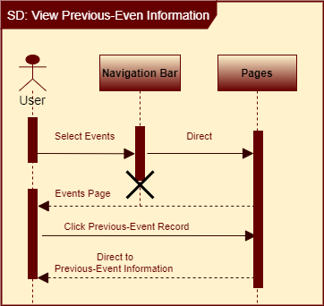

Figure View Previous-Events Sequence Diagram

## Previous-Events Officers-View

This will display the same page explained in the Upcoming-Events Officers-View. for more information refer to sections ‎(3.5 Events and section 22 Upcoming-Events Officers-view).

### Add Previous-Event

Once the officer clicks this Add button under the Previous-Events title, he/she will be directed to the “Add Form” form. The “Add Form” form consists of the following fields and buttons**:**

#### Add Previous-Event Form Look and Feel

The “Add Form” form consist of the following fields and buttons**:**

Table Fields Details in Add Previous-Event form

|  |  |  |  |  |  |  |
| --- | --- | --- | --- | --- | --- | --- |
| Label | Description | Value | Format | Type | Size | Required |
| Title | Event Title field | User Input | Text | Character | 50 bytes | Yes |
| Date | Previous Event date – must take past dates | User Input | MM/DD/YYYY | Numeric | 3 Bytes | Yes |
| Body | Event content description field | User Input | Text | Character | 3000 Bytes | Yes |
| Attachments | Images and files | User Input | PNG, GIF, PDF | Image | 5MB/item | No |

The “Add Upcoming Event” form contains the following buttons:

* Add ---> saves change and reflects the Event record under the Upcoming-Events title.
* Cancel ---> reverts all changes.

**The figure below illustrates the “Add Previous-Event” form look and feel:**

Figure Add Previous-Event form

#### Add Previous-Event Use-Case

|  |  |  |  |  |
| --- | --- | --- | --- | --- |
| **Use Case Definition** | | | | |
| **Actors** | | | Officer | |
| **Description** | | | Allows Officers to create a Previous-Event record and reflect it on the Events Page under the Upcoming-Events title. | |
| **Preconditions** | | | Officer must complete login Use-Case main flow successfully (‎10.1.1.1 Login Use-Case) | |
| Main Flow | | | | |
| No. | | Actor Action | | System Response |
|  | | Actor clicks on the Events tab from the Navigation Bar. | | * System directs the actor to the Events page. * System displays up to 5 records of Upcoming-Events and 5 records of Previous-Events as clickable links. * System confirms current user is logged in to the system and display Add and Delete buttons. |
|  | | Actor clicks “Add Previous Event” button | | System directs the user to the “Add Form” form. |
|  | | Actor fills all mandatory fields correctly and presses the “Add” button | | * System confirms all mandatory fields are filled correctly including the record row number. * System reflects the new Previous-Event record on the “Events” page under “Previous-Events” title as a clickable link in the specified row. * System creates the corresponding “Previous-Event Information” page for the new Previous-Event record. |
| Alternative Flow | | | | |
| No. | Actor Action | | | System Response |
|  | Actor fills all mandatory fields correctly and presses the “Cancel” button | | | System does not reflect any changes and returns the Officer to the “Events” page. |
| Exceptional Flow | | | | |
| No. | Actor Action | | | System Response |
|  | Actor fails to fill all mandatory fields correctly and presses “Add” button | | | System displays error message containing the fields labels that need to be filled or corrected. |
|  | Actor clicks on the “Events” tab from the Navigation Bar | | | * System directs the actor to the “Events” page. * System displays up to 5 records of Upcoming-Events and 5 records of Previous-Events as clickable links. * System confirms current user is **not** logged in to the system and hides the Add and Delete buttons sets. |
| Post Conditions | | | | |
| Replaced Previous-Event records must be archived in database. | | | | |

#### Add Previous-Event Sequence Diagram

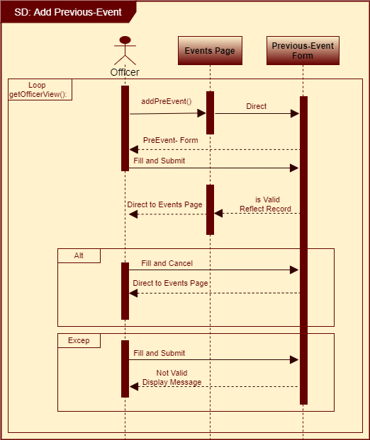

Figure Add Previous-Event Sequence Diagram

### Delete Previous-Event record

The “Delete” button in the “Events” page that appear in the Officers-View under the “Previous-Events” title will allow officers to delete Previous-Events records.

* The Delete button will have **burgundy** color to indicate its **Active state**.
* The Delete button will be disabled (unclickable) by default and marked with **gray** color to indicate its **Disabled state**.

#### Delete Previous-Event Use-Case

|  |  |  |  |  |
| --- | --- | --- | --- | --- |
| **Use Case Definition** | | | | |
| **Actors** | | | Officer | |
| **Description** | | | Allows Officers to delete Previous-Event records and remove them from Events page | |
| **Preconditions** | | | Officer must complete login Use-Case main flow successfully (‎10.1.1.1 Login Use-Case) | |
| Main Flow | | | | |
| No. | | Actor Action | | System Response |
|  | | Actor clicks on Events tab from the Navigation Bar | | * System directs the actor to Events page. * System displays up to 5 previous events records as clickable links. * System confirms current user is logged in to the system and displays the Add and Delete buttons. |
|  | | Actor clicks Delete button next to the desired record to be deleted. | | * System asks the actor to confirm deletion. |
|  | | Actor clicks “yes” to confirm. | | * System removes the corresponding record from Events page. * System displays a delete confirmation message. * System disables the delete button. |
| Alternative Flow | | | | |
| No. | Actor Action | | | System Response |
| None | | | | |
| Exceptional Flow | | | | |
| No. | Actor Action | | | System Response |
|  | Actor clicks on Events tab from the Navigation Bar | | | * System directs the actor to Events page. * System displays up to 5 previous events records as clickable links. * System confirms current user is **not** logged in to the system and hides the Add and Delete buttons. |
| Post Conditions | | | | |
| None | | | | |

# Officers

The officers page will display images and information regarding the association’s members. In addition, it will be the destination of Officers and the Administrators to login to the MHAA-USNR system.

* As of all pages/screens on the MHAA-USNR website this page must follow the unified pages look specified in section ‎(5.1 Unified Pages look).
* Under the navigation bar the page will display information regarding the current MHAA-USNR Officers. Each record will display the Officer’s personal picture and on the right side of the picture, his/her name, and brief information.
* Officers who wish to login to the MHAA-USNR system will first navigate to this page and then enter their credentials (username and password) in the login box that will appear on the top right corner of this page.

**The figure below illustrates the Officers page look and feel:**

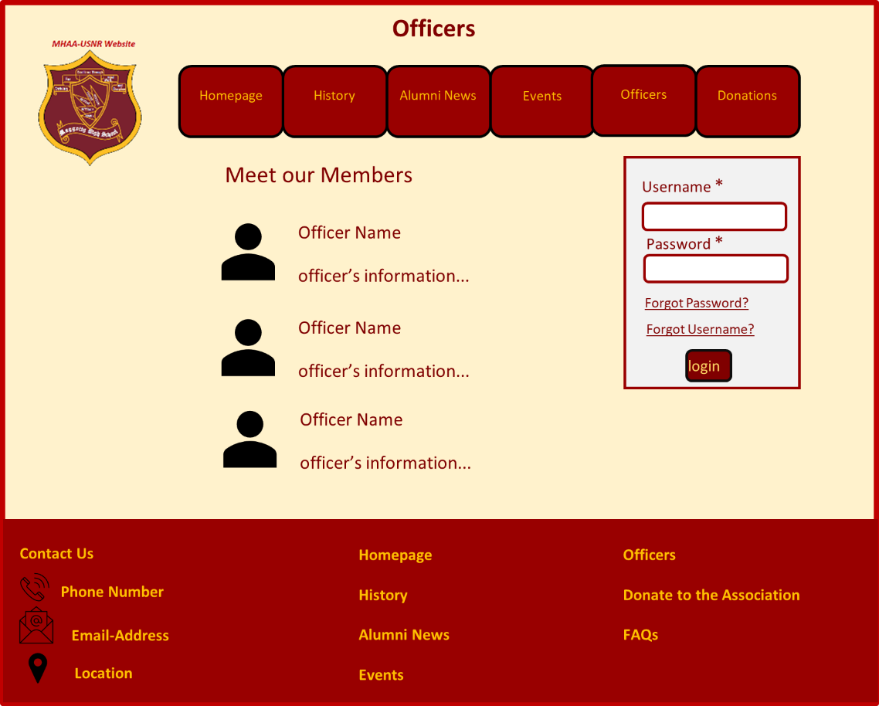

Figure Officers Page Look and Feel

## Officers Login

* Officers with pre-set username and password, will be able to login to the MHAA-USNR system. Once logged in successfully officers will be permitted to see extra content on the Alumni News page and the Events page as discussed in sections (‎3.4.2 Alumni News Officers-View)(3.5.2Upcoming-Events Officers-view‎ )(3.5.4 Previous-Events Officers-View).
* After a successful login, a logout link will appear at the right top corner of each page of the system.
* The login box will reside on the officer’s page on the top right corner under the navigation bar, and will contain the following:
* Log-in **fields**, the below table describes these fields:
* A **forgot password** link and a **forgot username** link.

Table Fields Details in Login Box

|  |  |  |  |  |  |  |
| --- | --- | --- | --- | --- | --- | --- |
| Label | Description | Value | Format | Type | Size | Required |
| Username | A unique value given to each officer | User Input | Text | Characters | 50 Bytes | Yes |
| Password | A unique value given to each corresponding username | User input | Text | Characters | 50 Bytes | Yes |

### Login/Logout Use-Case

|  |  |  |  |  |
| --- | --- | --- | --- | --- |
| **Use Case Definition** | | | | |
| **Actors** | | | Officer and Administrator | |
| **Description** | | | 1. Allows Officers to login to the MHAA-USNR system and gain officer view and privileges. 2. Allows the Administrator to login to the MHAA-USNR system and gain administrator view and privileges | |
| **Preconditions** | | | Officers/Administrator must have their preset username and password | |
| Main Flow | | | | |
| No. | | Actor Action | | System Response |
|  | | Actor clicks on the Officers tab from the Navigation Bar. | | * System directs the actor to the Officers page. |
|  | | Actor enters his/her Username and password in the corresponding fields in the login box and clicks the “Login” button. | | * System checks if the entered password and username are match. * System directs the Actor to the “Homepage”. * System shows a welcome message displaying the corresponding Actor name. * System checks the entered username and password. * IF the entered username and password combination is of an Officers, the system grants the actor Officer View and privileges. * IF the entered username and password combination is of an Administrator, the system grants the actor Administrator View and privileges. |
|  | | Actors clicks on Logout link. | | * System directs the actor to the “Homepage”. * System hides Officer’s Administrator’s view privileges. * System returns to user view. |
| Alternative Flow | | | | |
| None | | | | |
| Exceptional Flow | | | | |
| No. | Actor Action | | | System Response |
|  | Actor enters invalid username | | | * System displays error message stating that the username/password are not correct * System does not direct the actor to the Homepage. * System does not activate Officers/Administrator View |
| Post Conditions | | | | |
| Officers must be granted privileges and remain in Officers View until they logout of the system.   1. Administrator must be granted privileges and remain in Administrator View until he/she logout of the system. 2. After a successful logout, the system returns to user view and hides any buttons related to editing page content. | | | | |

#### Login Sequence Diagram

Figure Login Sequence Diagram

## Forgot Password?

* The “Forgot Password?” link will direct the officers to a page that contains a field via which the officers must enter their linked email address in order receive an email with reset password link.

The figure below illustrates the look and feel of the forgot password page:

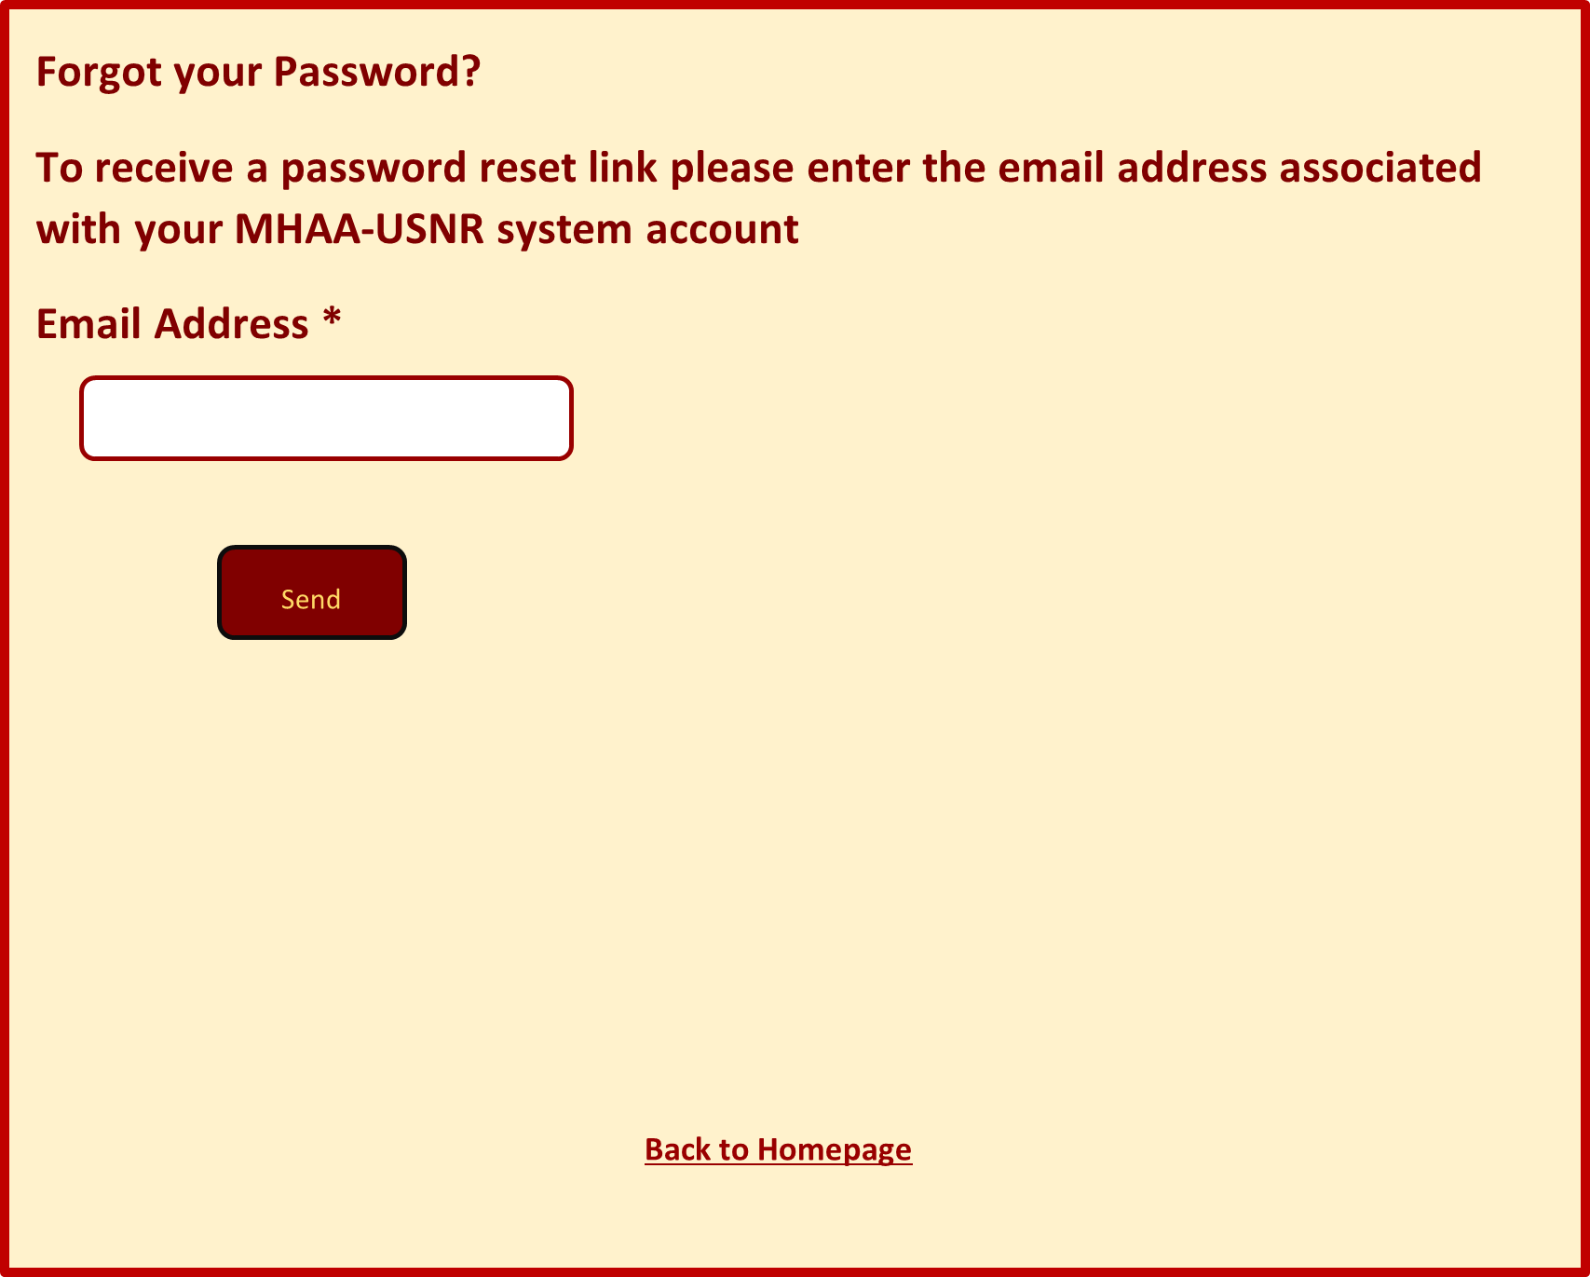

Figure Forgot Password Page

* If the officer enters a correct email address (an email address that is associated with an officer’s account), the system will issue an email that contains a link to reset the password. Once the officer clicks on the link sent to the email address the system will direct him/her to the reset password page.

**The figure below illustrates the look and feel of the password reset page:**

Figure Reset Password Page

* After the officer changes his/her password successfully and clicks the “submit” button, he/she will be directed to a confirmation page that displays a success message.

**The figure below illustrates the look and feel of the password change success message page:**

Figure Password Change Success Page

### Forgot Password Use-Case

|  |  |  |  |  |
| --- | --- | --- | --- | --- |
| **Use Case Definition** | | | | |
| **Actors** | | | Officer | |
| **Description** | | | Allows Officers change the password required for login | |
| **Preconditions** | | | Officers must have access to the email address linked to the MHAA-USNR system. | |
| Main Flow | | | | |
| No. | | Actor Action | | System Response |
|  | | Actor clicks on the Officers tab from the Navigation Bar. | | System directs the actor to the Officers page. |
|  | | Actor clicks on the “forgot password?” link from the login box. | | System directs the Actor to the “Forgot Password” Page. |
|  | | Actor enters his linked email address in the “Email Address” Field and clicks “Send”. | | System sends an email to the entered email address containing a link to change the password. |
|  | | Actor clicks the link sent to his/her email address | | System directs the Actor to the “Reset Password” page. |
|  | | Actor fills all mandatory fields and clicks “Submit”. | | * System confirms all mandatory fields are filled. * System confirms the entered password matches specified Criteria * System confirms “New Password” and “Confirm Password” fields input data matches. * System directs the Actor to a confirmation page stating his/her password is changed successfully * System reflect the new password on the Database and link it to the corresponding officer Username. |
| Alternative Flow | | | | |
| None | | | | |
| Exceptional Flow | | | | |
| No. | Actor Action | | | System Response |
|  | Actor enters invalid email address (an email address not linked to an officer in the MHAA-USNR system) and clicks “Send”. | | | * System displays error message stating that the officer entered and invalid email address * System does not send an email to the entered email address |
|  | Actor does not fill all mandatory fields and clicks “Submit”. | | | * System fails to confirm all mandatory fields are filled. * System shows an error message containing the fields that need to be filled. * System does not direct the Actor to a confirmation page. * System does not reflect the new password on the Database. |
|  | Actor fills all mandatory fields and clicks “Submit”. | | | * System fails to confirm the entered password matches specified Criteria * System shows an error message stating that the password does not match criteria. * System does not direct the Actor to a confirmation page. * System does not reflect the new password on the Database. |
|  | Actor fills all mandatory fields and clicks “Submit”. | | | * System fails to confirm “New Password” and “Confirm Password fields” input data matches. * System shows an error message stating that the “New Password” and “Confirm Password” fields do not match. * System does not direct the Actor to a confirmation page. * System does not reflect the new password on the Database. |
| Post Conditions | | | | |
| * officer must be able to login using the new password * System must not allow login using the old/replaced password | | | | |

## Forgot Username?

* The “Forgot Username?” link will direct the officers to a page that contains a field via which the officers must enter their linked email address to receive an email containing their Username.

**The figure below illustrates the look and feel of the “Forgot Username” page:**

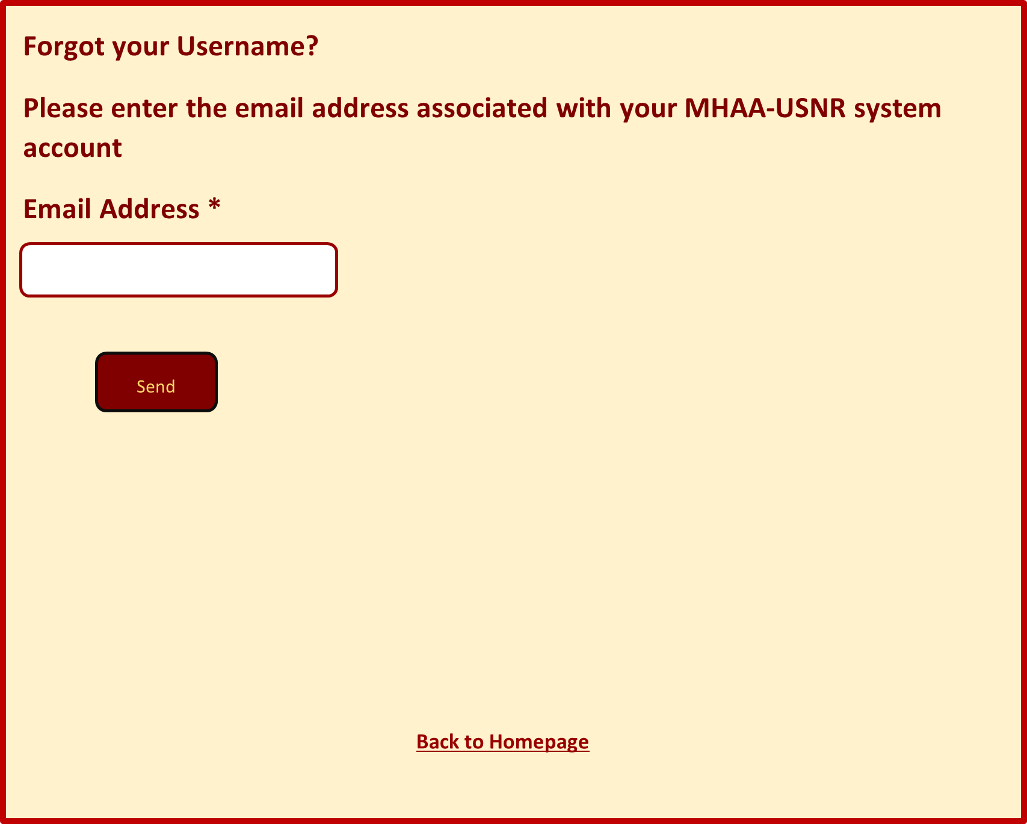

Figure Forgot Username Page Look and Feel

* If the officer enters a correct email address (an email address that is associated with an officer’s account), the system will issue an email that contains the Username that is associated with the entered email address and will direct the user to a confirmation page that contains a message stating that an email was successfully sent.

**The figure below illustrates the look and feel of the Username confirmation page:**

Figure Username confirmation page

### Forgot Username Use-Case

|  |  |  |  |  |
| --- | --- | --- | --- | --- |
| **Use Case Definition** | | | | |
| **Actors** | | | Officer | |
| **Description** | | | Allows Officers to retrieve their associated MHAA-USNR system username. | |
| **Preconditions** | | | Officers must have access to the email address linked to the MHAA-USNR system. | |
| Main Flow | | | | |
| No. | | Actor Action | | System Response |
|  | | Actor clicks on the Officers tab from the Navigation Bar. | | System directs the actor to the Officers page. |
|  | | Actor clicks on the “forgot Username?” link from the login box. | | System directs the Actor to the “Forgot Username” Page. |
|  | | Actor enters his linked email address in the “Email Address” Field and clicks “Send”. | | System sends an email to the entered email address containing the corresponding Username. |
| Alternative Flow | | | | |
| None | | | | |
| Exceptional Flow | | | | |
| No. | Actor Action | | | System Response |
|  | Actor enters invalid email address (an email address not linked to an officer in the MHAA-USNR system) and clicks “Send”. | | | * System displays error message stating that the officer entered and invalid email address * System does not send an email to the entered email address |
| Post Conditions | | | | |
| None | | | | |

# Donations

Via this page, the system will provide the option for users to send funds to the association using: Visa, Mastercard, and PayPal as payment methods.

**The Donations page will contain the following fields and buttons:**

Table Donation Page Fields Details

|  |  |  |  |  |  |  |
| --- | --- | --- | --- | --- | --- | --- |
| Label | Description | Value | Format | Type | Size | Required |
| Donation Amount | The amount of funds in US Dollars | User Input | Numeric | Positive Float | 4 bytes | Yes |
| First name | User First Name | User Input | Text | Character | 50 Bytes | No |
| Last name | User Last Name | User Input | Text | Character | 50 Bytes | No |
| Email address | User Email address | User Input | Text | Character | 350 Bytes | No |
| Phone Number | User Phone Number | User Input | Numeric | Integer | 4 Bytes | No |

The “Donations” page contains the following buttons:

* Donate ---> takes the user to the **“Payment Information”** form.

**The figure below illustrates the Donations page look and feel:**

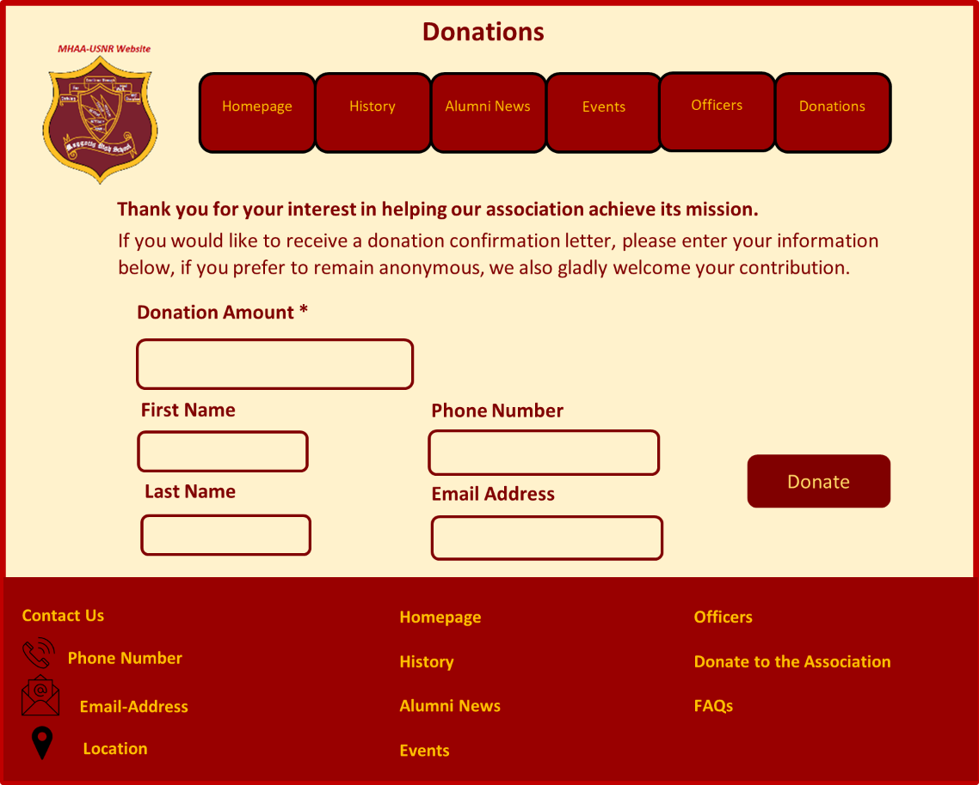

Figure Donations Page look and feel

## Payment Information Form

The user will be directed to this page after he/she enters a fund amount in the “Donation Amount” filed in the “Donation” page and clicks the “Donate” button.

The user will be directed to “Payment Information” form which was discussed and described in detail in section (‎9.1.2.2 Payment Information form). Please refer to the linked section for more information.

## Payment Confirmation Page

After completing the “Payment Information” form successfully and posting the payment, the user will be directed to this page to view his/her receipt number and confirmation details.

The confirmation page will view the following information

Table Content of Donation confirmation Page

|  |  |
| --- | --- |
|  | Description |
| A thank you message, | **Thank You!**  **Your Donation was received successfully and will be put to good use!** |
| Donation Amount | The system will retrieve the amount the user entered in the “Donations" page. |
| Donation Number | A unique number generated automatically for each new Fund Donation. The number must contain letters and number. |
| Philanthropist | The system will retrieve the First and Last name the user entered in the “Donations" page. (If any) |
| Email Address | The system will retrieve the Email Address the user entered in the “Donations" page. (If any) |
| Phone Number | The system will retrieve the Phone Number the user entered in the “Donations" page. (If any) |
| Date | Current days’ date (system generated). |
| Contact us message | Displays Client specified email address and phone number |
| Back to home link | A clickable link takes the user back to the website’s Homepage. |

**The figure below illustrates the look and feel of the Donation Confirmation Page:**

Figure Donation Confirmation Page Look and Feel

## Donate Use-Case

|  |  |  |  |  |
| --- | --- | --- | --- | --- |
| **Use Case Definition** | | | | |
| **Actors** | | | Users | |
| **Description** | | | Allows users to donate funds to the association using the MHAA-USNR system e-payments | |
| **Preconditions** | | | Actor must enter the website URL on a supported device browser. | |
| Main Flow | | | | |
| No. | | Actor Action | | System Response |
|  | | Actor clicks on the “Donations” tab from the Navigation Bar | | * System directs the actor to the “Donations” page. |
|  | | Actor fills all mandatory fields correctly and presses “Donate” button | | System direct the user to the “Payment Information” form. |
|  | | Actor fills all mandatory fields correctly and presses “Pay” button. | | * System adds the donation record to the database. * System generates a Donation number. * System directs the user to the “Donation Confirmation” page. * System checks if the user entered an email address and sends a confirmation email if true. |
| Alternative Flow | | | | |
| None | | | | |
| Exceptional Flow | | | | |
| No. | Actor Action | | | System Response |
|  | Actor fails to fill all mandatory fields correctly and presses “Donate” button | | | System displays error message containing the fields labels that need to be filled or corrected. |
|  | Actor fails fills all mandatory fields correctly and presses “Pay” button | | | System displays error message containing the fields labels that need to be filled or corrected. |
| Post Conditions | | | | |
| Completed Donations must be reflected on Database | | | | |

# Unified Email Notifications

Any email issued by the MHAA-USNR system must be of unified look and feel and must reflect the following in addition to the specified information for each corresponding email:

* All emails sent to users and officers must reflect the system name and logo.
* All emails must reflect the association contact information.
* All emails must contain the appropriate email title according to the type of email sent.

**The figure below illustrated the unified emails look and feel:**

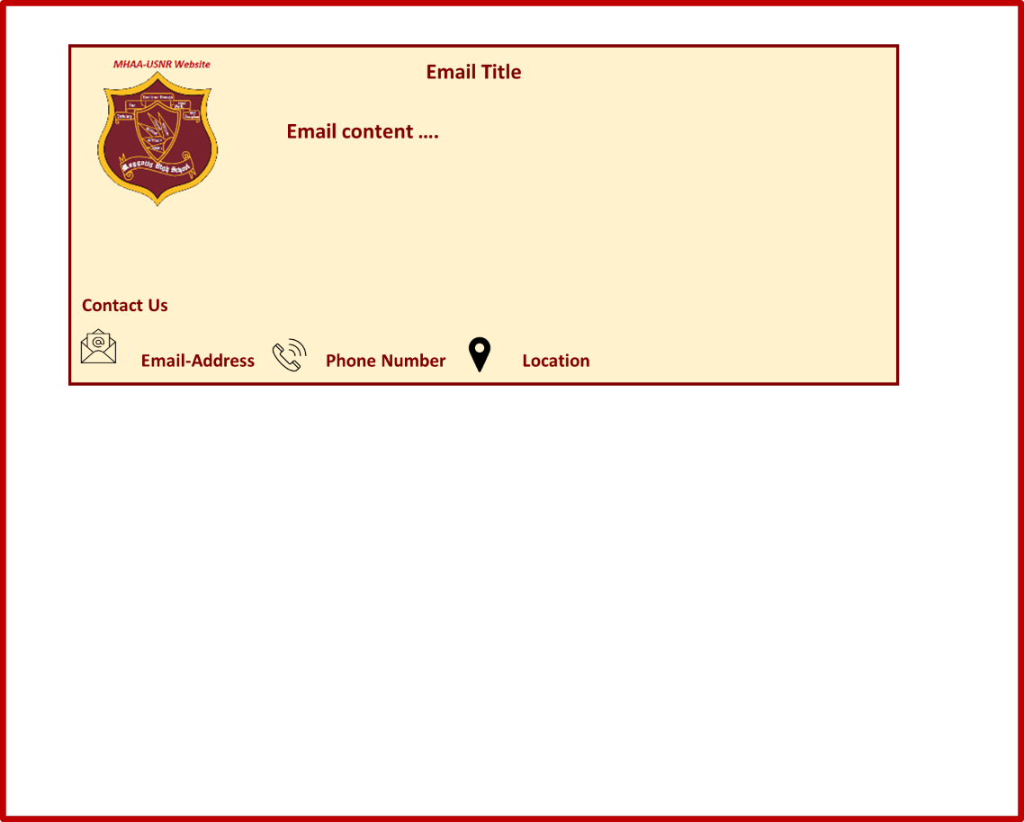

Figure Unified Email Look and Feel

## Details in the MHAA-USNR System Emails

The MHAA-USNR system will issue the following emails:

### Registration Confirmation Email

Users who complete registration in an event via the “Event Registration” form discussed in section (‎10.1.2 Event Registration), will receive an email, this email contains the following:

* As of all Emails notifications sent by the MHAA-USNR system this email must follow the Unified Email Notifications specified in section (3.9 Unified Email Notifications).
* This email must reflect the following information
* A thank you message the client will specify.
* The unique registration number associated with the registered user.
* The registered user full name (first name and last name).
* The registered user email address.
* The registered user phone number.
* The corresponding event’s title.
* The corresponding event’s time.
* The corresponding event’s date.
* The corresponding event’s location.
* The corresponding event’s fee.

### Donation Confirmation Email

Users who donate fund to the association via the “Donation” page discussed in section (‎12 Donations) will receive an email. This email contains the following:

**Note**: this email will be sent if the user chooses to add his/her personal information in the donations page, and the email will reflect the information this user chose to include.

* As of all Emails notifications sent by the MHAA-USNR system this email must follow the Unified Email Notifications specified in section (3.9 Unified Email Notifications).
* This email must reflect the following information
* A thank you message the client will specify.
* The unique Donation number associated with the user.
* The registered user full name (first name and last name).
* The registered user email address
* The registered user phone number
* Donation amount

### Password Reset Email for Officers

Officers who issue a Password reset email via the “Forgot Password?” link discussed in section (‎11.2Forgot Password?), will receive an email that contains the following:

* As of all Emails notifications sent by the MHAA-USNR system this email must follow the Unified Email Notifications specified in section (3.9 Unified Email Notifications).
* This email must reflect the following information
* Officer name
* Password reset link, that directs the Officer to the “Reset Password”.

### Username Reset Email for Officers

Officers who issue a username reset email via the “Forgot Username?” link discussed in section (‎11.3Forgot Username?), will receive an email that contains the following:

* As of all Emails notifications sent by the MHAA-USNR system this email must follow the Unified Email Notifications specified in section (3.9 Unified Email Notifications).
* This email must reflect the following information
* Officer name
* The corresponding Officer Username.
* start session (user view)

# Administrator

The Administrator is a special user of the MHAA-USNR system who will be granted an Administrator view privileges and ability to change pages content.

## Administrator View

1. The administrator must log in to the system via the login box in the “Officers” page using his/her preset username and password to be granted the Administrator View.
2. A “Change” button will appear in pages and sections the administrator is permitted to change
3. Each “change” button opens a corresponding form containing the items in the page that he/she will be able to change.

### Administrator Change Privileges

The administrator will be permitted to change the following:

1. Contact Us information in the bottom section.
2. Homepage text content
3. History Page text content
4. Questions and Answers in the FAQs page.
5. Ability to add and delete:

* News records in the “Alumni News” page
* Upcoming-Event records in the “Events” page.
* Previous Events records in the “Events” page.

### Administrator Privileges Use-Case

Note this Use-Case applies and can be repeated for each page of the system.

|  |  |  |  |  |
| --- | --- | --- | --- | --- |
| **Use Case Definition** | | | | |
| **Actors** | | | Administrator | |
| **Description** | | | Allows the Administrator to change specified content in the MHAA-USNR pages | |
| **Preconditions** | | | The Administrator must complete login Use-Case main flow successfully (‎10.1.1.1 Login Use-Case) | |
| Main Flow | | | | |
| No. | | Actor Action | | System Response |
|  | | Actor clicks on the Home Page from the Navigation Bar | | * System directs the actor to the “Homepage”. * System confirms current user is logged in to the system as Administrator and displays a “Change” Buttons for the page content and a “Change Contact Us” button for the bottom section. |
|  | | Actor clicks “Change” button located near the page content. | | System directs the user to the corresponding form to change the page’s text. |
|  | | Actor fills in the form and clicks “Submit”. | | System changes the corresponding content in the page. |
|  | | Actor clicks “Change Contact Us” button located at the bottom section. | | System directs the user to the corresponding form to change the “Contact Us” information. |
|  | | Actor fills in the form and clicks “Submit”. | | System changes the corresponding content in the page. |
| Alternative Flow | | | | |
| None | | | | |
| Exceptional Flow | | | | |
| No. | Actor Action | | | System Response |
|  | Actor clicks on the Home Page from the Navigation Bar | | | * System directs the actor to the “Homepage”. * System confirms current user is **not** logged in to the system and hides the “Change” Buttons. |
| Post Conditions | | | | |
| None | | | | |

Appendixes

1. Terms

|  |  |  |
| --- | --- | --- |
| No. | Term | Definition |
|  | Administrator | Special user with advanced permission to edit and delete website content |
|  | Client | Maggotty High Alumni Association –US Northern Region |
|  | FAQs | Frequently Asked Questions |
|  | GUI | Graphical User Interface |
|  | MD5 | Message-Digest algorithm 5 |
|  | MHAA-USNR | Maggotty High Alumni Association –US Northern Region |
|  | No. | Number |
|  | Officers | Alumni Association members |
|  | PCs | Personal Computers |
|  | PMDs | Personal Mobile Devices |
|  | Req. | Requirement (Client specified) |
|  | SRS | System Requirements Specification |
|  | URL | Uniform Resource Locator |
|  | Users | Anyone with an access to the internet and the website link |
|  | Username | A unique name given to the officers to login to the system |

1. Class Diagram

